ProjetoRHCofril
PGHOST='ep-blue-frost-ad6pf00o-pooler.c-2.us-east-1.aws.neon.tech'
PGDATABASE='bdcofril'
PGUSER='neondb_owner'
PGPASSWORD='npg_z8fDyvuC5ScI'
PGSSLMODE='require'
PGCHANNELBINDING='require'
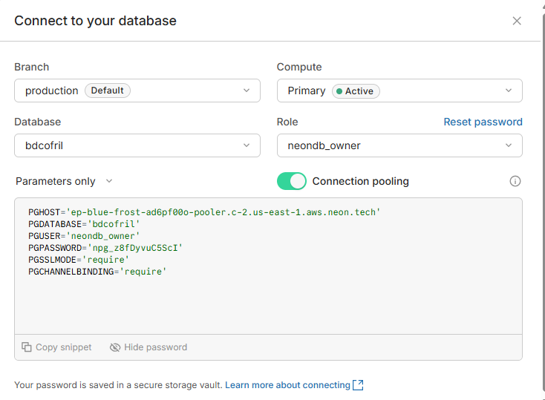

Neondb-ProjetoSESMTCofril
PGHOST='ep-aged-mud-acujtw7g-pooler.sa-east-1.aws.neon.tech'
PGDATABASE='neondb'
PGUSER='neondb_owner'
PGPASSWORD='npg_c2NT9unRCFpd'
PGSSLMODE='require'
PGCHANNELBINDING='require'
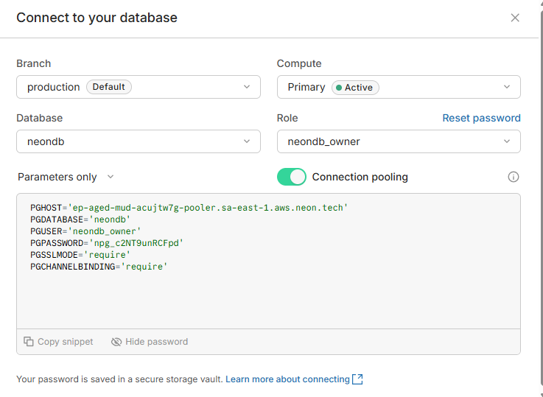

ProjetoSESMTCofril

PGHOST='ep-aged-mud-acujtw7g-pooler.sa-east-1.aws.neon.tech'
PGDATABASE='bdsesmt'
PGUSER='neondb_owner'
PGPASSWORD='npg_c2NT9unRCFpd'
PGSSLMODE='require'
PGCHANNELBINDING='require'

